DATE: | VERSION: | PRODUCT NUMBER: | PRODUCT NAME:
22/07/2024 | 4 | 1-779 | Christmas Pudding

PRODUCT DESCRIPTION
A delicious individual Christmas pudding, made using traditional methods, with a perfect balance of the finest ingredients, including real Rum.

PRODUCT INGREDIENT DECLARATION
Ingredients: Sultanas (21%) (Sultanas, Vegetable Oil), Wheat Flour (Vitamins (Thiamin, Folate)), Brown Sugar, Canola Oil, Currants (Sunflower Oil), Water, Margarine (Vegetable Oil, Water, Milk Solids, Salt, Emulsifiers (471, 322 (Soy)), Natural Flavour, Food Acid (330), Natural Colour (160a), Vitamins A & D), Shortening (Soy) (Vegetable Oils, Emulsifiers (435, 471), Antioxidant (307b)), Candied Orange Peel (Contains Acidity Regulator (330)), Colour (150a), Golden Syrup, Rum (2%) (Colour (150a)), Breadcrumbs (Contains Wheat), Humectant (420), Brandy Essence (Contains Colour (150a)), Orange Paste (Contains Preservative (202)), Egg Powder, Stabiliser (471), Ginger, Mixed Spice, Preservative (202).

ALLERGEN DECLARATION
Contains Gluten, Wheat, Egg, Milk, Soy.
May Contain Almond, Hazelnut, Macadamia, Pecan, Pistachio, Walnut.

PRODUCT SPECIFICATIONS: 1-779 Plum Pudding
Individual Product Weight | 106g
Carton Weight | 4.77kg
No. of Units per Inner | 45
No. of Units per Outer | 1
Pallet Dimensions | Ctns per Layer: 15 | No. of Layers: 9 |  | Ctns/ pallet: 135
Barcodes  (Including check digit) | EAN N/a | TUN 1933104302400(4)
Shelf life | Primary: 728 days | Secondary: 7 days Ambient Once Thawed
Outer Dimensions (m) | Height: 110mm | Length: 355mm | Width: 220mm
Outer Packaging | Corrugated Fibre Board
Country of Origin | 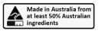
Methods of Preservation | Frozen
Heating Instructions | To serve from frozen, heat on HIGH in microwave for approximately 30 seconds.
Halal Status | NOT Suitable

MICROBIAL SPECIFICATIONS
Parameter | Specification
Standard Plate Count | <1x10⁴ cfu/g
Yeast and Mould | <1x10³ cfu/g
Coliforms | <100 cfu/g
E. coli | <3 cfu/g
Listeria monocytogenes | ND in 25g
Salmonella | ND in 25g

LABEL SAMPLES
OUTER LABEL SAMPLE
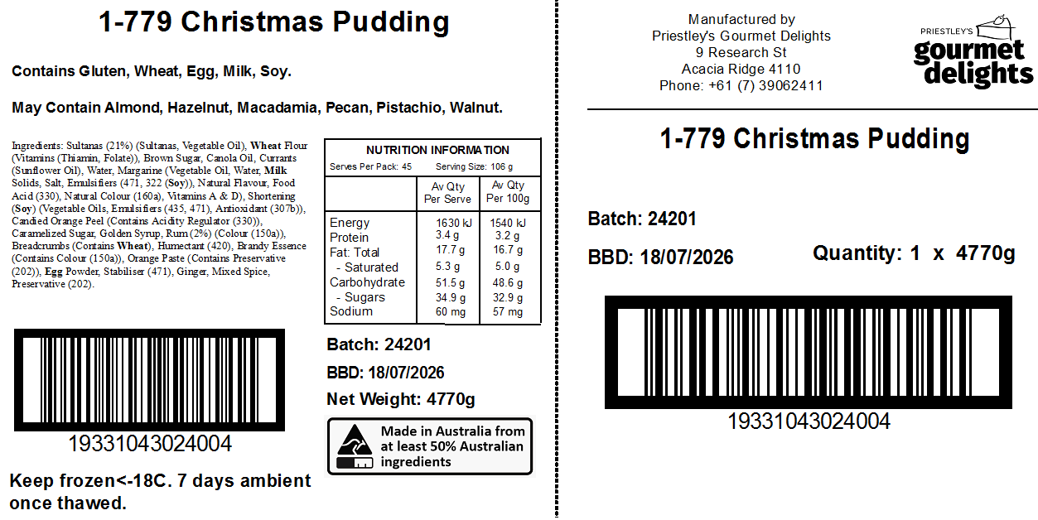
PRODUCT IMAGE:
