Product Specifications Banana Bread

**Product Description** Large sized loaf banana bread

**Dietary** N/A

**Packaging Profile** Food grade cardboard bake in box

**Storage/Shelf Life** Refrigerated below 5 degrees C (7 days from date of manufacture) Frozen Solid (6 months frozen shelf life)

**Distribution** Product to be delivered below 5 degrees C by approved Victorian distributor/contractor. Product to be delivered frozen solid by approved Interstate distributor/food service

**Customer Suitability** Suitable for general consumption. Persons with intolerances to specific allergens to avoid. Contains Gluten, Egg and their products. May contain traces of Dairy, Soybeans, Tree Nuts, Peanuts and their products.

**Final Customer Preparation** Cut loaf into 15 slices.Recommended to warm sliced product in microwave for approximately 20 seconds prior to serving or heat in toaster till warmed through.

|  |  |  |  |  |
| --- | --- | --- | --- | --- |
| Banana Bread | | Large | | ❑ |
|  | |  |
| Ingredients in order of in going weight; Banana (36%), Wheat Flour, Egg, Vegetable Oil, Brown Sugar, White Sugar, Raising Agents, Vanilla, Cinnamon  Contains gluten, egg and their products - May contain milk, peanuts, tree nuts, sesame seeds, soybeans - and their products  Made from local and imported ingredients | Serving Size: 175g | | | |
| Serves per 2.28kg cake - 13 | | | |
|  | | | |
| **Nutrient** | **Avg. quantity per serve** | **Quantity per 100g** | |
| Energy (kJ) | 2160 | 1230 | |
| Protein (g) | 7.8 | 4.5 | |
| Fat, total (g) | 21.2 | 12.1 | |
| Fat, saturated (g) | 3.1 | 1.8 | |
| Carbohydrate (g) | 71.0 | 40.6 | |
| Sugars (g) | 44.0 | 25.2 | |
| Sodium (mg) | 276 | 158 | |
| **Marks Quality Cakes ~ 1 Akuna Drive Williamstown 3016 Victoria AUSTRALIA 03 9397 4677 Store below 4°C** | | | | |

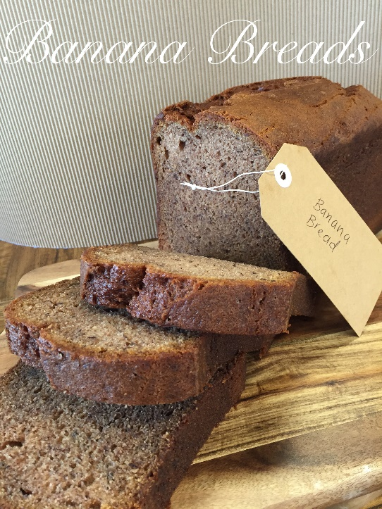

Version 1.0 Issued 27/03/2018 Issued by Allie Klaman