Product Specifications Florentines

|  |  |  |
| --- | --- | --- |
| PRODUCT: FLORENTINES (GLUTEN FREE) - 20 x 45g | | |
|  | Product Description | 20 florentines coated with chocolate underneath and a red glaze cherry on the top. |
|  | Ingredients | Corn flakes gluten free (maize flour, sugar, maltodextrin, salt, emulsifier 471), glace cherries (cherries, glucose-fructose syrup, sucrose, preservatives (potassium sorbate, sulphur dioxide), food acid (citric), colour (127)), compound chocolate (sugar, vegetable fat, cocoa powder, milk solids, emulsifiers (soy lecithin, 476), flavour), condensed milk (milk, sugar), almonds, sultanas, vegetable oil). |
|  | Packaging Profile | 20 pieces x 40g  Primary packaging: Poly bags.  Secondary packaging: Pastry box. |
|  | **Storage and shelf life** | Store in airtight packaging or container at 15° to 24°C  Shelf life 3 months from date of manufacture. |
|  | **Distribution and customer suitability** | Product to be delivered ambient or under 5°.  Suitable for general consumption. Persons with allergies or reactions to specific ingredients to avoid. Contains milk, soybean, tree nuts, peanuts & sulphites. May contain traces of peanuts & their products. |
|  | **Final customer preparation** | Serve from pack. Ready-to-eat - no preparation required. |

|  |  |  |  |  |  |
| --- | --- | --- | --- | --- | --- |
| NUTRITION INFORMATION | | | | | |
| Servings per package: | | 20 | | | |
| Average serving size: | | **45g** | | | |
|  | Average quantity per serving | | | Average quantity per 100g | |
| Energy | 784 | | kj | 1740 | kj |
| Protein | 2.1 | | g | 4.7 | g |
| Fat total | 5.0 | | g | 11.0 | g |
| - saturated | 2.9 | | g | 6.5 | g |
| Carbohydrate | 32.9 | | g | 73.1 | g |
| - sugars | 17.4 | | g | 38.6 | g |
| Sodium | 34 | | mg | 76 | mg |

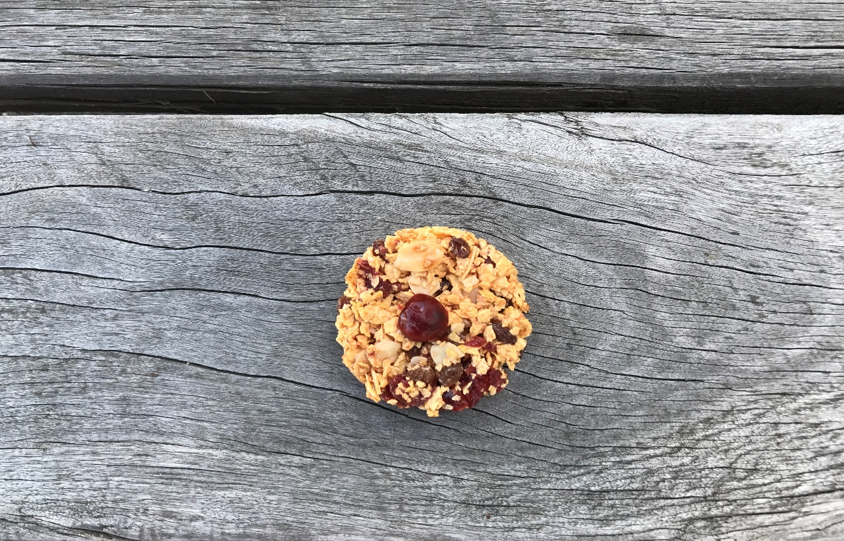

Version 2.0 Issued 17/05/2022 Issued by Neeta V.