|  |  |  |
| --- | --- | --- |
| PRODUCT: CHOC CHIP CHUNK – 20 X 65g | | |
|  | Product Description | 20 round shaped cookies with choc chip chunks. |
|  | Ingredients | Wheat flour (flour, thiamine), cane sugar, butter (pasteurised cream (milk), water), whole egg, caster sugar, compound chocolate (sugar, vegetable fat, cocoa, whey powder (milk), emulsifiers (soya lecithin, 492), flavours, salt), compound chocolate (sugar, vegetable fat, cocoa powder, emulsifiers (soya lecithin, 476, 492), flavours, cocoa solids), glucose syrup (contains sugar (from wheat), preservative (220)), margarine (contains soya lecithin, milk solids non-fat), vanilla essence, sodium bicarbonate (500), baking powder (raising agent (450, 500), wheat starch), salt |
|  | Packaging Profile | 20 pieces x 65g  Primary packaging: Poly bags.  Secondary packaging: Pastry box. |
|  | **Storage and shelf life** | Store in airtight packaging or container at 15° to 24°C  Shelf life 3 months from date of manufacture. |
|  | **Distribution and customer suitability** | Product to be delivered ambient or under 5°.  Suitable for general consumption. Persons with allergies or reactions to specific ingredients to avoid. Made on equipment that also processes products with gluten, eggs, milk, nuts, & soy beans. Contains wheat, dairy, soy beans & their products. |
|  | **Final customer preparation** | Serve from pack. Ready-to-eat - no preparation required. |

|  |  |  |  |  |  |
| --- | --- | --- | --- | --- | --- |
| NUTRITION INFORMATION | | | | | |
| Servings per package: | | 20 | | | |
| Average serving size: | | 65g | | | |
|  | Average quantity per serving | | | Average quantity per 100g | |
| Energy | 1112 | | kj | 1710 | kj |
| Protein | 5.5 | | g | 8.5 | g |
| Fat total | 9.8 | | g | 15.1 | g |
| - saturated | 5.4 | | g | 8.4 | g |
| Carbohydrate | 39.3 | | g | 60.5 | g |
| - sugars | 18.5 | | g | 28.4 | g |
| Sodium | 127 | | mg | 196 | mg |

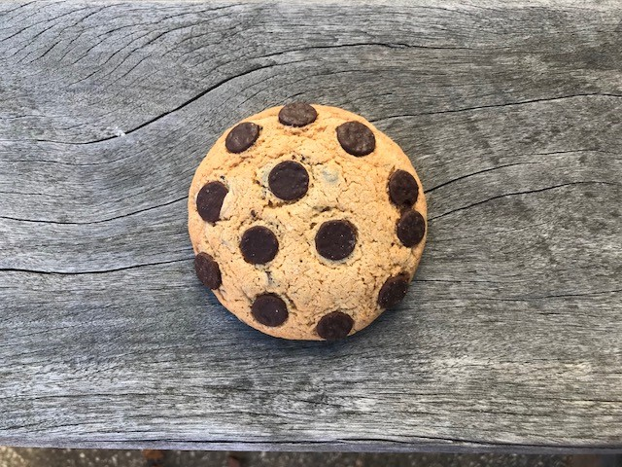

Version 2.0 Issued 17/05/2022 Issued by Neeta V.